Beverly Hills Bar Association
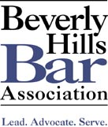

Barristers

COMMITTEE FOR THE ARTS

CFTA is proud to present
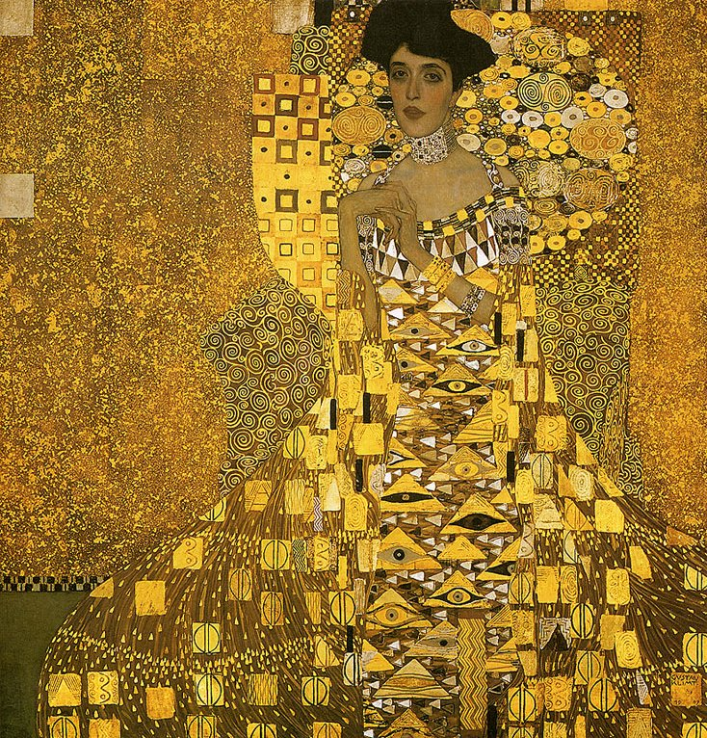

An Evening in Honor of

E. Randol Schoenberg

”Outstanding Attorney for Justice”

May 31, 2006

5:00 p.m. – 8:00 p.m.
Los Angeles County Museum of Art (LACMA)
Leo S. Bing Theater
5905 Wilshire Boulevard

Registration: 4:30 p.m. – 5:00 p.m.

Film Screening: 5:00 p.m. – 6:00 p.m.

Klimt: Adele's Last Will
2006; 52 minutes; director, Michel Vuillermet; producer, Dissidents/Laurence Uebersfeld

Price: $45 - General Public
$55 - MCLE (BHBA Member)
$65 - MCLE (Non-BHBA Member)

Program: 6:00 p.m. – 7:00 p.m.

Opening remarks by Irena Raskin, Esq., President, Beverly Hills Bar Association Barristers and Chair, Beverly Hills Bar Association Barristers Committee for the Arts

Remarks by Don Burris, Esq. Burris & Schoenberg

Presentation of Outstanding Attorney for Justice Award to E. Randol Schoenberg, Esq. by Cynthia Pasternak, Esq., President, Beverly Hills Bar Association

Discussion of Altmann v Republic of Austria

Questions from the audience to E. Randol Schoenberg and Maria Altmann

Reception and 7:00 p.m. – 8:00 p.m.

Private Viewing: Wine and appetizers catered by Patina

Five Paintings from the Collection of Ferdinand and Adele Bloch Bauer

Parking: Please use the parking lot at the corner of Spaulding Avenue and Wilshire Boulevard across the street from the main entrance at a rate of $5.

Co-Sponsor: Los Angeles County Museum of Art

Gold Sponsor: Novak & Ben-Cohen

Sponsorship Available: Gold - $1, 000: Includes 4 free tickets and acknowledgement in Event announcements.

Bronze - $500: Includes 2 free tickets and acknowledgement in Event announcements.

Program Chair: Irena Raskin, Esq.
To REGISTER for this program:
Print and FAX this flyer to (310) 601-2423 or mail it to BHBA, Post Office Box 7277, Beverly Hills, CA 90212-7277
Online registration is only for attorneys seeking MCLE credit http://bhba.org/event.htm
If you would like to receive flyers by mail or to register by phone, call (310) 601-BHBA
-------------------------------------------------------------------------------------------------------------------------------------------COMMITTEE FOR THE ARTS "An Evening in Honor of E. Randol Schoenberg – Outstanding Attorney for Justice” May 31, 2006
Name:_______________________________________ BHBA Member______ Bar#____________
Firm:____________________________________________________________________________
Address:_________________________________________________________________________
Zip:____________________________ Phone:_________________________________
____Enclosed is my check for $___________ Make checks payable to BHBA
_____Charge $__________________ on my _______Visa ______MasterCard ______AMEX
Card#_____________________________________________ Exp:________________
2 HOURS MCLE CREDIT: This activity has been approved for Minimum Continuing Legal Education credit by the State Bar of California in the amount of 2 hours and the Beverly Hills Bar Association certifies that this activity conforms to the standards for approved education activities prescribed by the rules and regulations of the State Bar of California governing minimum continuing legal education.
To find out more about the CFTA and our upcoming programs, please visit our web page at www.bhba.org/Committees_Sections/CFTA.htm

